Name:_______________________________ Date:____________
TAXONOMY/CLASSIFICATION QUEST
INTRODUCTION:
Scientists believe that there are over 10 million different kinds of life forms, or species, on Earth. Imagine trying to study and understand the lives, patterns, behaviors and evolution of so many different kinds of organisms. In order to make their job easier, scientists classify living things into groups based on how they are the same and how they are different.
As an example, think of Halloween candy. On Halloween night after returning from trick or treating, what did you and your friends do? Many kids pour their candy out on the floor or bed and begin separating the candy into piles based on how the candy items are the same and how they are different.
Biologists do the same thing with life-forms. Instead of dumping all the life-forms on the floor and placing them in piles, scientists write down which group each type of organism belongs to.
Scientists who classify living things are called taxonomists. It is their job to look at every kind of living thing and determine how they are similar and how they are different to other living things.
Here is where it gets a little tricky. A life-form might be very similar to one living thing, but less similar to another, and even less similar to a third living thing. For example, a dog is very similar to a wolf, less similar to a horse, and very different from a lizard.
To help scientists keep this all straight, they start by classifying, or by placing life-forms in groups called kingdoms. These kingdoms represent a very large group of life-forms that are all similar in some ways, but can be very different from one another in other ways. The Six kingdoms that biologists have developed are the Archeabacteria Kingdom, the Eubacteria (true bacteria) Kingdom, the Protist Kingdom, the Fungi Kingdom, the Plant Kingdom, and the Animal Kingdom.

TASK:
YOUR TASK IS TO NAVIGATE THROUGH A SERIES OF WEB PAGES AND INVESTIGATE AND LEARN NEW KNOWLEDGE ABOUT BIOLOGICAL CLASSIFICATION / TAXONOMY.
As you navigate through this Quest, be sure to explore the selected areas in more depth, if needed.
BEGIN THE QUEST:
I. IN THE BEGINNING…
GO TO: http://animals.about.com/od/animalswildlife101/a/diffprokareukar.htm
1. All living organisms can be sorted into one of two groups depending on the fundamental structure of their cells. These two groups are the ________________________________ and __________________________.
Prokaryotes:
2. What are prokaryotes?
3. Describe the DNA in a Prokaryotic Cell?
4. Scientists have divided the Prokaryotes into two groups. What are they?
Eukaryotes:
5. What are eukaryotes?

II. Using your search and navigation web skills, find the scientific definition of “TAXONOMY and TAXONOMIST”
6. TAXONOMY –

7. TAXONOMIST –

III. GO TO - http://www.kidsbiology.com/biology_basics/classification/kingdom3.php
8. What is the category (the largest or broadest group) that Taxonomists place organisms into first?

9. What is the next category or group that Taxonomists place organisms into?
If we decide that the organism we want to classify is not a bacterium, protist, fungi or plant, it is an Animal.
10. Animals with a backbone belong to what Phylum?

11. How many Classes are under the phylum Chordata?

Each time we place an organism into a smaller group, or one lower in the hierarchy, the organisms become more and more similar – or more closely related.
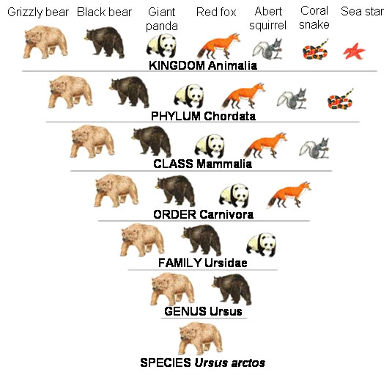
LOOK BELOW AT THE HEIRARCHIAL CLASSIFICATION PYRAMID FOR THE GRIZZLY BEAR:

12. What Kingdom does the Grizzly Bear Belong to?
13. What other organisms belong to the same kingdom?
14. What Class does the bear belong to?
15. What Order?
16. What Family?
17. What Genus?
Finally the species! The Grizzly Bear’s scientific name is Ursus Arctos. This two-part scientific name identifies the grizzly bear by its genus and species.
18. What is the most specific category – genus or species?

IV. GO TO: https://www.khanacademy.org/science/biology/tree-of-life/v/species
Watch the video (you can pause and rewind as much as you need to. If you have earbuds, use them. I can supply them if you don’t)
19. What is a species?
20. What does interbreed mean?
21. Are all dogs members of the same species?
V. Binomial nomenclature – GO TO: http://www.scienceprofonline.com/biology-general/biological-classification-binomial-nomenclature.html
22. Carl Linnaeus (1707-1778), a Swedish physician and botanist, was the founder of what?
23. He originated a system called?
Binomial Nomenclature is the formal system for naming organisms.
24. What two hierarchical categories are used in the Binomial Nomenclature system when naming an organism?
All living things, and even some viruses, have a scientific name.
25. Having a scientific name for every organism that lives or has once lived on Earth, avoids what?
26. How is an organisms name written in the Scientific community (underlined, italicized or both)?
27. What is the scientific name for humans?
VI. GO TO: http://animals.about.com/od/scientificdisciplines/a/classifyinganim.htm
28. Who developed the first know method of classification?
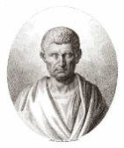
29. How did Aristotle, a famous Greek philosopher, scientist, and educator,
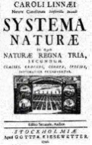
classify organisms?
30. In what year did Carolus Linnaeus, the Swedish Biologist, introduce
his classification system?
31. The system is referred to as what?
32. How does the Linnaean Taxonomy system categorize organisms?
33. Based on what?
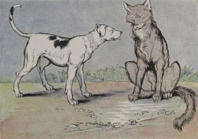
34. What does the Linnaean Taxonomy system use to categorize organisms?

35. List the hierarchy of levels form kingdoms to species in order from broad to most specific

1. Kingdom
2.
3.
4.
5.
6.
7. Species

36. Navigate the World Wide Web and Place the human into each of the seven hierarchical taxonomic categories, beginning with Kingdom and ending with the scientific name.

1. Kingdom - Animalia
2. Phylum - ? _______________
3. Class - ? _______________
4. Order - ? _______________
5. Family - ? _______________
6. Genus - ? _______________
7. Species - sapiens
**A good way to remember the hierarchical order of the Linnaean is to make up a mnemonic using the first letters in a list. In this case we want to remember Kingdom, Phylum, Class, Order, Family, Genus, Species: K, P, C, O, F, G, S For example:
King Philip Came Over For Good Spaghetti
Or
Keep Plates Clean Or Family Gets Sick
37. Come up with your own mnemonic to remember Linnaeus’ Levels of Classification.
______________________________________________________________
38. Although the Linnaean System is still used today, it is no longer the only method for grouping or classifying organisms – true or false?

GO to Page 3
39. What is the definition of taxon?

40. With the invention of the microscope in the mid-1700’s scientists discovered a new world of organisms – what do YOU THINK they were?
41. Biological classification is always changing. As our knowledge of organisms expands through advances in biology and related science, we gain a better understanding of the similarities and differences among various groups of organisms. These vast changes to classification have led to the recent reorganization of the dinosaur – more like a bird than a reptile – true or fase?
GO TO PAGE 4
41. The two kingdom system was introduced by Aristotle in 4th century B.C. (a long time ago…). He classified animal into two main groups based on what he observed about the characteristic of the organism. What were the two groups?
42. The three kingdom system was introduced in what year and by whom?
43. The three kingdom system included what three kingdoms?
1.
2.
3.
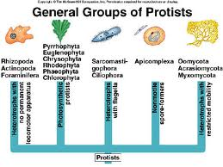
44. Protista are usually single-celled organisms. What type of cells (prokaryotic or eukaryotic) are Protists?
44. Based on what you know about prokaryotic and eukaryotic cells, are protists simple or complex organisms?

45. Are bacteria prokaryotic or eukaryotic?

46. The four Kingdom classification system was introduced in 1956 to include bacteria as its own kingdom. Based on what you know about cell types, why do you think Bacteria was moved to its own kingdom?

47. In 1959, a Five Kingdom System was introduced and it remained in place for almost 20 years. Robert Whittaker added a fifth kingdom to four kingdom system, what was it?

48. What are Fungi?

49. What name was the Kingdom Bacteria changed to in the Five Kingdom System?
50. In 1977, Carl Woese, a microbiologist, devised the Six Kingdom System, extending Robert Whittaker's Five Kingdoms to replace Kingdom bacteria with what two kingdoms?

51. Eubacteria and Archaebacteria differ in their genetic characteristics – true or false?

52. In 1990, Woese, proposed a three DOMAIN SYSTEM. What are they?
1.
2.
3.

VII. SCROLL DOWN THE PAGE AN CLICK on The Three Domain System:
Based on all current information we have about the countless number of organisms that occupy or once occupied the Earth, The three Domain is currently the best classification system we have …for now.
53. Fill in the Blanks - The Three Domain System:
1. Archaea Domain-
Contains the _________________ Kingdom
2. Bacteria Domain –
Contain the __________________ Kingdom
3. Eukarya Domain-
Contains the –
_________ Kingdom
_________ Kingdom
_________ Kingdom
_________ Kingdom
VIII. What about Viruses? GO TO: http://www.ducksters.com/science/biology/viruses.php
54. What are viruses?

55. Are viruses alive?
56. Why are viruses bad?
57. What are examples of some Viruses?
LOOK UNDER - Interesting Facts about Viruses:
58. RE-WRITE the first sentence here – it’s important!

